**Calculator Assumed**

**Applications of Anti-Differentiation 1**

Time: 45 minutes

Total Marks: 45

Your Score: / 45



**Question One: [3 marks] CA**

The area under the curve  over the domain  is  .

Determine the value of *k*.

**Question Two: [2, 2, 3, 3 = 10 marks] CA**

Consider the function 

1. 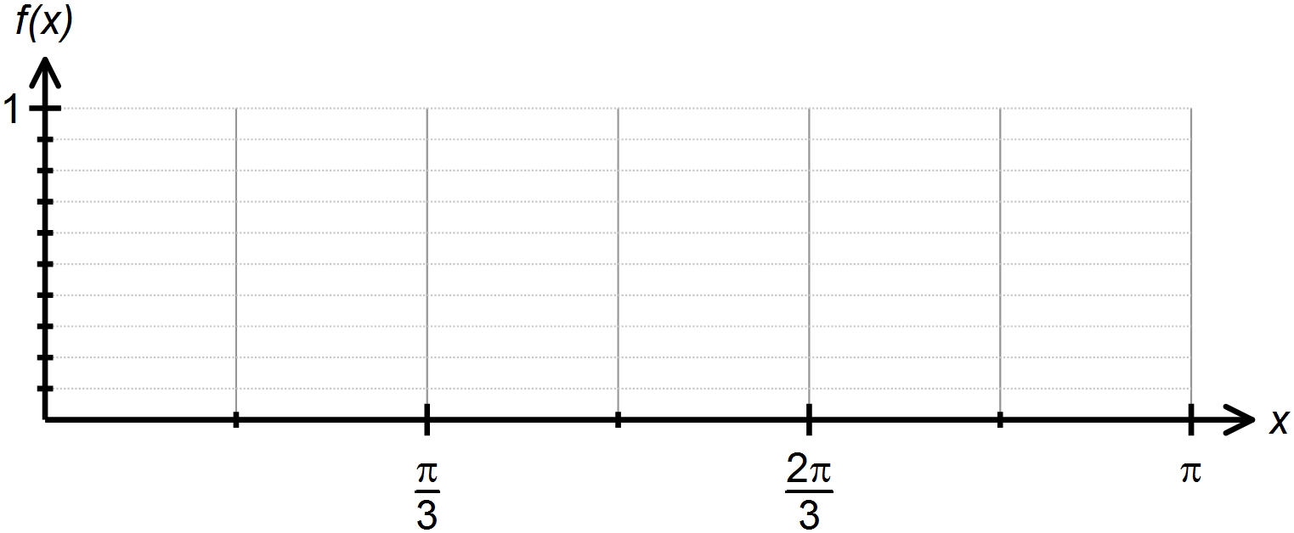Sketch  over the domain 
2. Draw rectangles on your graph that can be used to overestimate the area under  over the domain , where .
3. Hence approximate the area under the curve over the domain .
4. Calculate the margin of error between your answer in part (c) and the exact value of the area under the curve over the domain .

**Question Three: [1, 2, 2, 2, 2 = 9 marks] CA**

The acceleration of a particle moving in rectilinear motion is given by  , where *t* is time in seconds and  is ms-2. The initial velocity of the particle is -4 m/s.

1. Determine the initial acceleration of the particle.
2. Determine an expression for the velocity of the particle.
3. Calculate when the speed of the particle is 4 m/s.
4. Calculate the change in displacement in the first second.
5. Calculate the distance travelled in the third second.

**Question Four: [2, 2, 3 = 7 marks] CA**

The marginal cost of producing *x* units of a certain product is  dollars per unit.

1. Determine the extra cost associated with producing the 31st item.
2. Find the increase in cost if the production level is increased from 200 units to 500 units.
3. The marginal revenue from producing and selling *x* units of a certain product is  . Determine the profit function if the profit from producing 10 items is $38.33.

**Question Five: [4 marks] CA**

Calculate the area enclosed between the two curves  and  over the domain  .

Draw a sketch to support your solution.

**Question Six: [4 marks] CA**

The area of the shaded region of  below is 6 units2.

Determine the values of *a* and *b*.

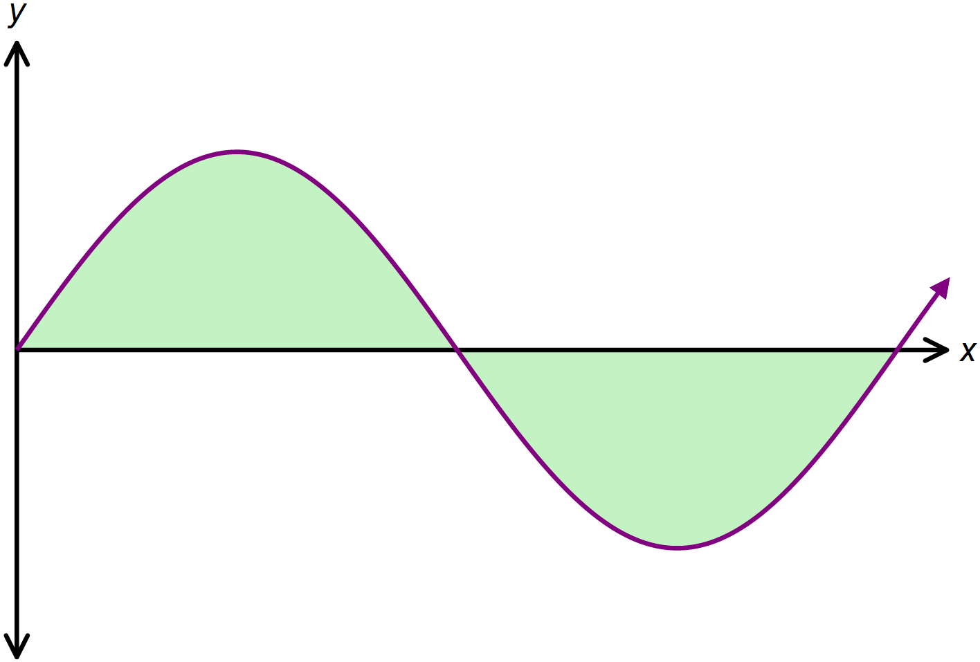

**Question Seven: [8 marks] CA**

The area bounded by the curve  and the *x* axis over the domain  is 10.5 units2.

The equation of the tangent to  at  is  .

Determine the values of *a, b* and *c.*

**SOLUTIONS**

**Calculator Assumed**

**Applications of Anti-Differentiation 1**

Time: 45 minutes

Total Marks: 45

Your Score: / 45



**Question One: [3 marks] CA**

The area under the curve  over the domain  is  .

Determine the value of *k*.



**Question Two: [2, 2, 3, 3 = 10 marks] CA**

Consider the function 

1. 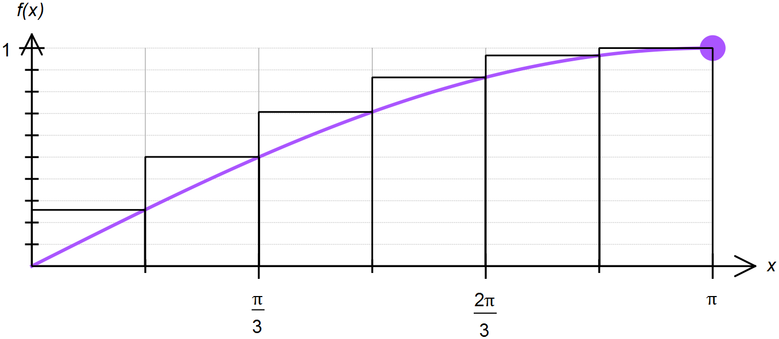Sketch  over the domain 







1. Draw rectangles on your graph that can be used to overestimate the area under  over the domain , where .
2. Hence approximate the area under the curve over the domain .





1. Calculate the margin of error between your answer in part (c) and the exact value of the area under the curve over the domain .



**Question Three: [1, 2, 2, 2, 2 = 9 marks] CA**

The acceleration of a particle moving in rectilinear motion is given by  , where *t* is time in seconds and  is ms-2. The initial velocity of the particle is -4 m/s.

1. Determine the initial acceleration of the particle.



1. Determine an expression for the velocity of the particle.



1. Calculate when the speed of the particle is 4 m/s.



1. Calculate the change in displacement in the first second.



1. Calculate the distance travelled in the third second.



**Question Four: [2, 2, 3 = 7 marks] CA**

The marginal cost of producing *x* units of a certain product is  dollars per unit.

1. Determine the extra cost associated with producing the 31st item.



1. Find the increase in cost if the production level is increased from 200 units to 500 units.



1. The marginal revenue from producing and selling *x* units of a certain product is  . Determine the profit function if the profit from producing 10 items is $38.33.



**Question Five: [4 marks] CA**

Calculate the area enclosed between the two curves  and  over the domain  .

Draw a sketch to support your solution.

 

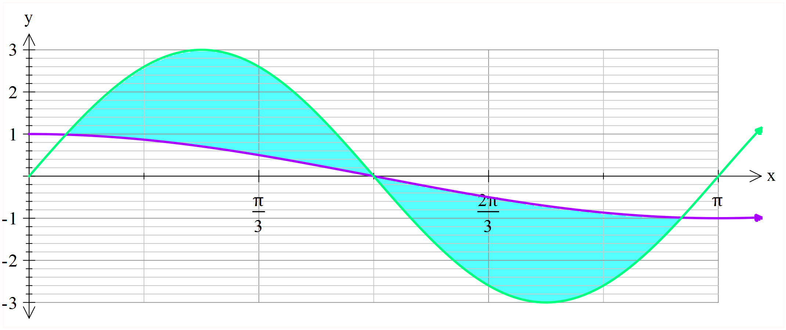

**Question Six: [4 marks] CA**

The area of the shaded region of  below is 6 units2.

Determine the values of *a* and *b*.



**Question Seven: [8 marks] CA**

The area bounded by the curve  and the *x* axis over the domain  is 10.5 units2.

The equation of the tangent to  at  is  .

Determine the values of *a, b* and *c.*

